
UGANDA SECONDARY SCHOOL SPORST ASSOCIATION BALL GAMES I

ACOLI ZONE, NWOYA DISTRICT- 14-20/4/2025
__________________________________________________________________________________________________________________________________

 |  |  |  |  | GROUPINGS |  | BOY | FIXTURES
GROUP A | GROUP B |  | CROUP C | GROUP D |  |  | GROUP E | GROUP F | GROUP G | GROUP H
1.RESTORE LHS | 1.NEGRI COLLEGE |  | 1.POPE VI | 1.PALLUDA |  |  | 1.ADILANG | 1.KORO SSS | 1.ISOKE | 1.LAGWAI
2.PATONGO SSS | 2.OGILI -PALABEK |  | 2.POPE II | 2.CALCUTA |  |  | 2.KITGUM MAIN | 2.AMURU HIGH | 2.P.P NEWTON | 2.FAVOUR HIGH
3.GULU CENTRAL | 3TREE OF LIFE |  | 3.AKWANG | 3.ST. MARY’S LACOR |  |  | 3.AWERE SSS-Abs | 3.KOCH GOMA | 3.RAC KOKO | 3.PAICHO SS
 | 4.PURONGO SEED-Abs- |  |  | 4.VIGNATO |  |  | 4.NORTHERN | 4.KITGUM STD | 4.STANDARD
 |  |  |  |  |  |  | HOPE |  | NWOYA


GROUP STAGE- BOYS

 | S/No | DATE |  | HOME TEAM | AWAY TEAM | GROUP | VENUE | TIME | RESULT
 |  | MONDAY 14/04/2025
 | 1 |  |  | RESTORE LEADERSHIP H S | GULU CENTRAL HIGH | A | Bidati P.7 | 10:00AM | 00-00
 | 2 |  |  | NEGRI COLLEGE | PURONGO SEED | B | Patira P.7 | 10:00AM | NP
 | 3 |  |  | POPE VI | AKWANG SS | C | Pope VI | 10:00AM | 00-02
 | 4 |  |  | ST. THERESA OF CALCUTA | PALUDA | D | Anaka P.7 | 10:00AM | 01-02
 | 5 |  |  | ST. MARY’S LACOR | VIGNATO | D | Corom P.7 | 10:00AM | 00-00
 | 6 |  |  | ADILANG SS | NORTHERN HOPE | E | Anaka Central P.7 | 10:00AM | 03-01
 | 7 |  |  | KORO SS | KITGUM STANDARD | F | Bidati P.7 | 2:00PM | 01-01
 | 8 | No Game |  | ISOKE | STANDARD NWOYA-Abs | G | Patira P.7 | 2:00PM | NP-NULL
 | 9 |  |  | LAGWAYI SEED | PAICHO | H | Pope VI | 2:00PM | 03-02
 | 10 |  |  | PATONGO SSS | RESTORE LEADERSHIP H S | A | Anaka P.7 | 2:00PM | 00-00
 | 11 |  |  | OGILI- PALABEK | PURONGO SEED | B | Anaka Central P.7 | 2:00PM | NP

A

B

C

D

E

F

G

H

LEGEND

S/No | DATE | HOME TEAM | AWAY TEAM | GROUP | VENUE | TIME | RESULT
 | TUESDAY 15/04/2025
12 | New | ST. JOHN PAUL II | POPE VI | C | Pope VI | 10:00AM | 01-00
13 |  | ST. MARY’S LACOR | ST. THERESA CALCUTTA | D | Patira P.7 | 10:00AM | 01-00
14 | No Game | KITGUM MAIN | AWERE SS-Abs- | E | Pope VI | 10:00AM | NP-NULL
15 |  | AMURU HIGH | KOCH GOMA | F | Anaka P.7 | 10:00AM | 00-00
16 |  | P.P NEWTON | RAC KOKO | G | Anaka Central P.7 | 10:00AM | 00-00
17 | New | TREE OF LIFE | OGILI | B | Patira P.7 | 2:00PM | 01-01
18 |  | VIGNATO | PALUDA | D | Corom P.7 | 2:00PM | 00-05
19 |  | NORTHERN HOPE | KITGUM MAIN | E | Pope VI | 2:00PM | 01-01
20 |  | KOCH GOMA | KITGUM STANDARD | F | Anaka P.7 | 2:00PM | 00-00
21 |  | P.P NEWTON | ISOKE | G | Anaka Central P.7 | 2:00PM | 02-01
S/No | DATE | HOME TEAM | AWAY TEAM | GROUP | VENUE | TIME | RESULT
 | WEDNESDAY 16/04/2025
22 | New | NEGRI COLLEGE | OGILI | B | Anaka P.7 | 10:00AM
23 |  | AKWANG SSS | ST. JOHN PAUL II | C | Patira P.7 | 10:00AM
24 |  | PALUDA | ST. MARYS LACOR | D | Pope VI | 10:00AM
25 | No Game | AWERE-Abs-NULL | ADILANG | E | Nill | 10:00AM | NP-NULL
26 |  | KORO SSS | KOCH GOMA | F | Anaka Central P.7 | 10:00AM
27 |  | ISOKE | RAC KOKO | G | Corom p.7 | 08:00AM
28 |  | FAVOR HIGH | LAGWAYI SEED | H | Corom P.7 | 10:00AM
29 | New | GULU CENTRAL HIGH | PATONGO SSS | A | Anaka P.7 | 2:00PM

A

B

C

D

E

F

G

H

LEGEND

S/No | DATE | HOME TEAM | AWAY TEAM | GROUP | VENUE | TIME | RESULT
 | THURSDAY 17/04/2025
30 | No Game | NORTHERN HOPE | AWERE SS | E | Nill | 10:00AM | NP-NULL
31 |  | KITGUM STANDARD | AMURU HIGH | F | Patira P.7 | 10:00AM
32 | No Game | RAC KOKO | STANDARD NWOYA-Abs | G | Pope VI | 10:00AM | NP-NULL
33 |  | FAVOR HIGH | PAICHO | H | Anaka P.7 | 10:00AM
34 |  | TREE OF LIFE | NEGRI COLLEGE | B | Anaka Central P.7 | 10:00AM
35 | New | ST. THERESA CALCUTA | VIGNATO | D | Anaka Central P.7 | 2:00PM
36 |  | KITGUM MAIN | ADILANG | E | Patira P.7 | 2:00PM
37 |  | AMURU HIGH | KORO SS | F | Pope VI | 2:00PM
38 | No Game | STANDARD NWOYA-Abs | P.P NEWTON | G | Anaka P.7 | 2:00PM | NP-NULL
39 | No Game | TREE OF LIFE | PURONGO SEED-Abs | B | Corom P.7 | 12:00PM | NP-NULL

LAST 16- KNOCKOUT

S/No |  |  | DATE | HOME TEAM | AWAY TEAM |  | VENUE | TIME | RESULT
 |  | FRIDAY 18/04/2025
40 |  |  |  | WINNER A | RUNNERS UP B |  | Pope VI | 10:00AM
41 |  |  |  | RUNNERS UP A | WINNER B |  | Anaka P.7 | 10:00AM
42 |  |  |  | WINNER C | RUNNERS UP D |  | Anaka Central P.7 | 10:00AM
43 |  |  |  | RUNNERS UP C | WINNER D |  | Patira P.7 | 10:00AM
44 |  |  |  | WINNER E | RUNNERS UP F |  | Pope VI | 2:00PM
45 |  |  |  | RUNNERS UP E | WINNER F |  | Anaka P.7 | 2:00PM
46 |  |  |  | WINNER G | RUNNERS UP H |  | Anaka Central P.7 | 2:00PM
47 |  |  |  | WINNER H | RUNNERS UP G |  | Patira P.7 | 2:00PM

A

B

C

D

E

F

G

H

LEGEND

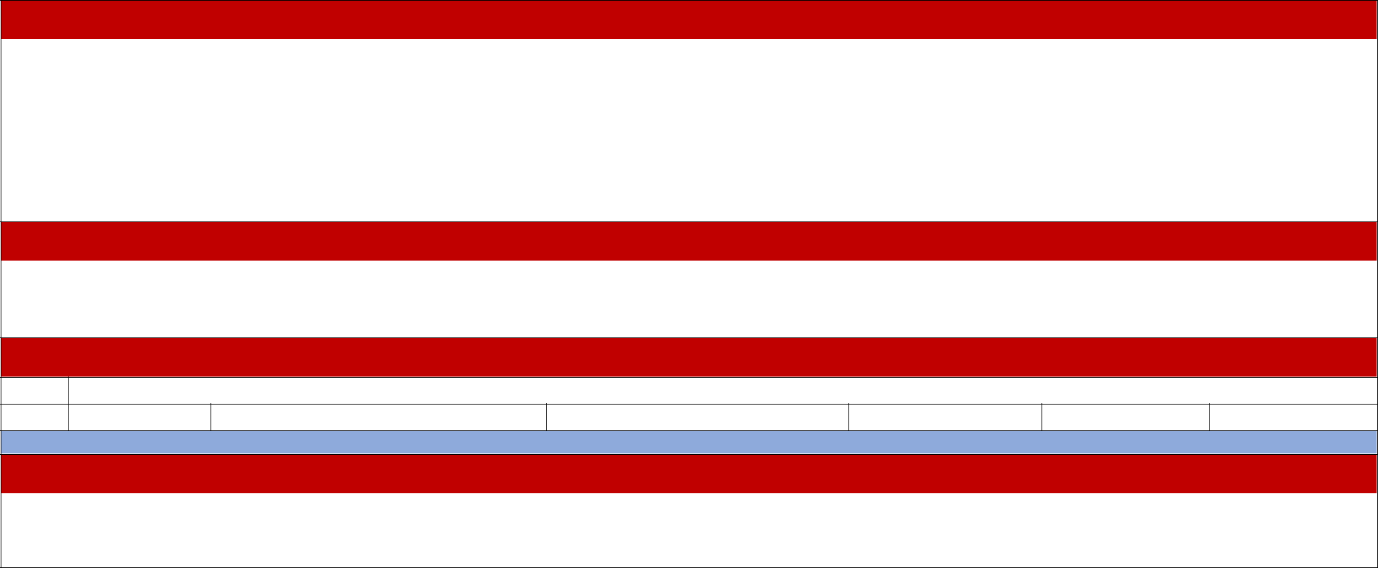
QUARTER FINAL
 | S/No | DATE | HOME TEAM | AWAY TEAM | VENUE | TIME | RESULTS
 |  | SATRUDAY 19/04/2025
48 |  |  | WINNER MATCH 40 | WINNER MATCH 41 | Bidati P.7 | 10:00AM
49 |  |  | WINNER MATCH 43 | WINNER MATCH 42 | Patira P.7 | 10:00AM
50 |  |  | WINNER MATCH 45 | WINNER MATCH 44 | P`ope VI | 10:00AM
51 |  |  | WINNER MATCH 46 | WINNER MATCH 47 | Anaka P.7 | 10:00AM

SEMI FINAL
51 |  |  | WINNER MATCH 48 | WINNER MATCH 49 | Anaka P.7 | 4:00PM
52 |  |  | WINNER MACH 51 | WINNER MATCH 50 | Anaka Central | 4:00PM

THIRD PLACE

 | SUNDAY 20/04/2025
53 | LOSER MATCH 51 | LOSER MATCH 52 | Anaka Central P.7 | 10:00AM

FINAL
 | 54 |  | WINNER MATCH 51 | WINNER MATCH 52 | Anaka Central P.7 | 3:00PM
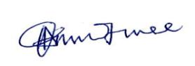
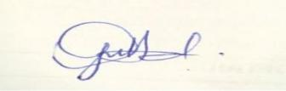
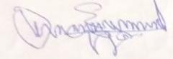

MR. OJUKU RICHARD BRIAN | MR. OLARA EMMANUEL YAGOS | MR. OJWEE DENNIS
Chairman Technical- Toc | Gen. Secretary- Toc | Chairman Technical
Tel: +256 7895 76524 | Tel: +256 7744 428311 | Committee- Secretariat
Tel: +256 772/756-663- 582
NB: Please, strictly arrive on the field of play 1 (one) hour before the kick off times

A

B

C

D

E

F

G

H

LEGEND

